

Updated: 9th August 2015

Advantages:

1. Product page is well organized.

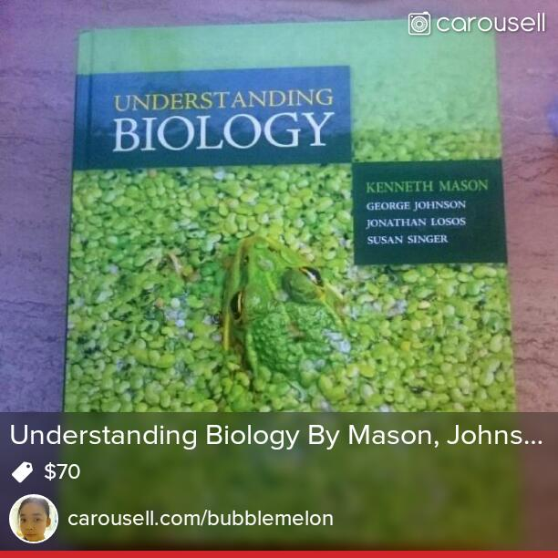 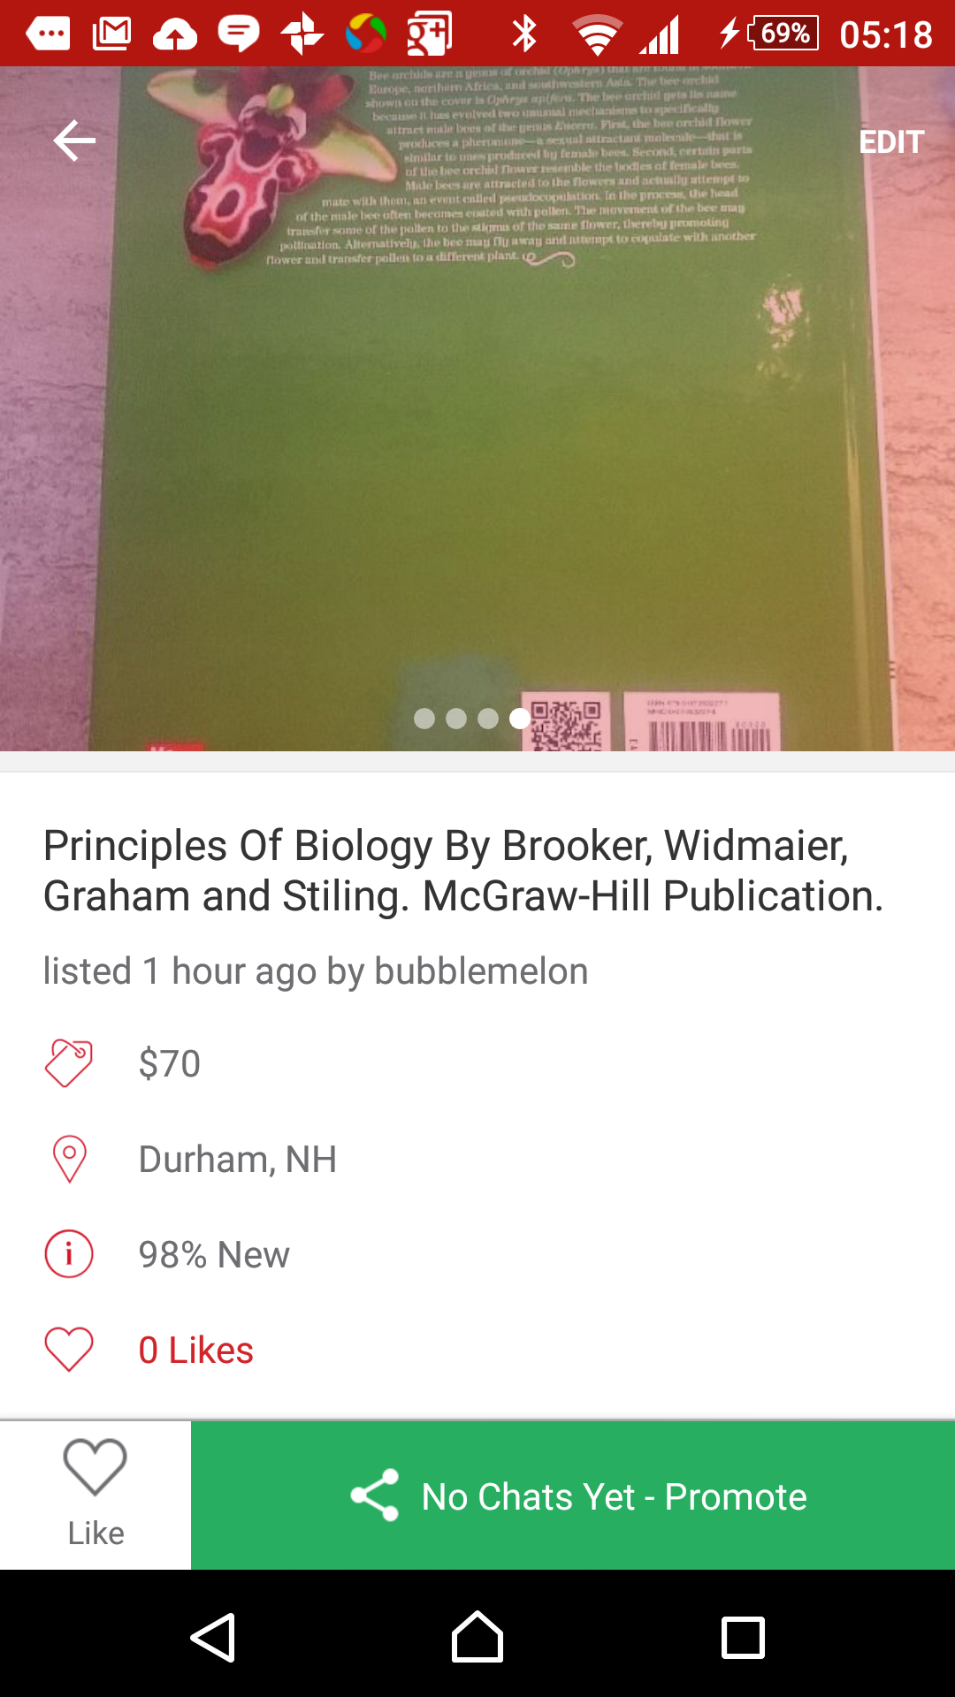 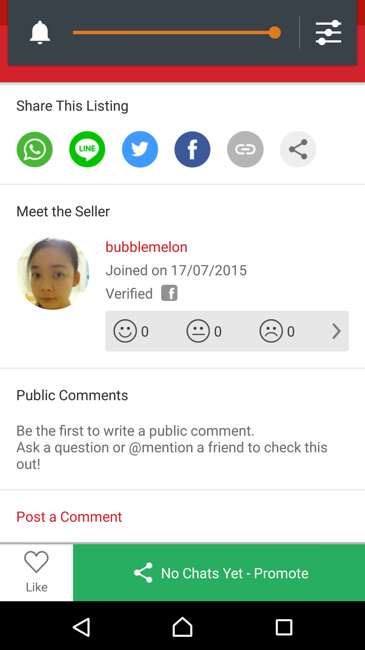

1. Buy & sell within different schools.
   1. Requested UNH to be on the list.

Item Details:

1. Promote Listing for free
2. Item name is very general. Name it the way you want.

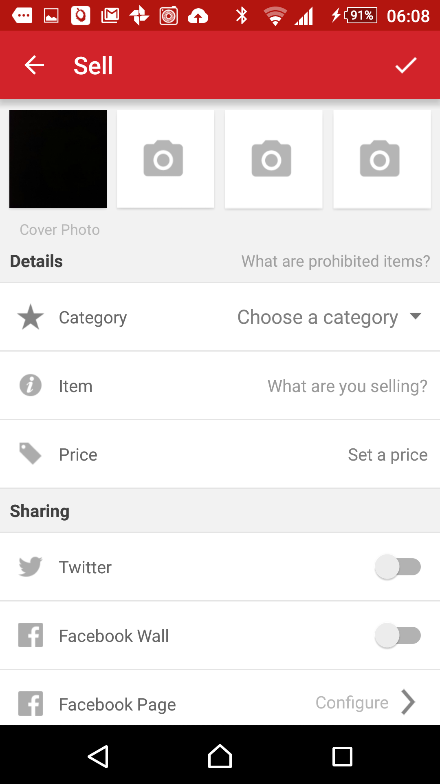

1. Must include:
   1. One photo
   2. Name of item
   3. Price
2. Provides you your own Carousell domain.
3. Includes filter for browsing different categories.
   1. Quick sell button access.

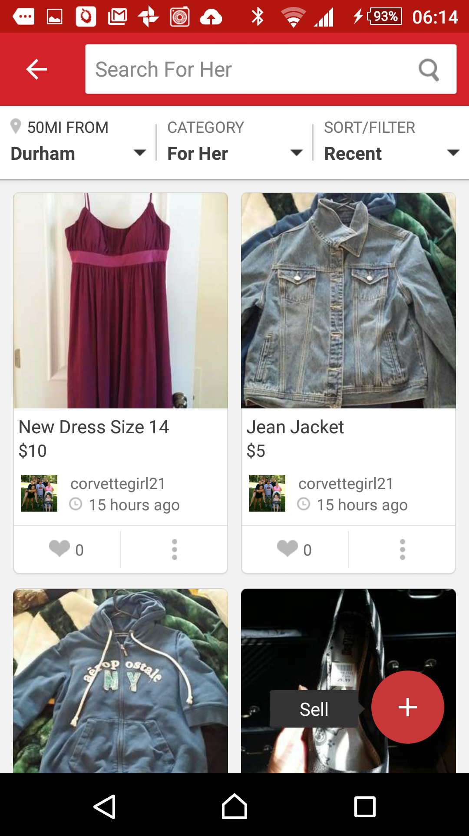

Disadvantages:

Making a listing

1. Bugs when taking photo
   1. Photo does not appear the same when being taken.
2. No option for shipping.
   1. Only meet to sell thing to people in the same area.
   2. Defeats the purpose of reaching out to a larger audience.
3. Only 4 photos.
4. Item description is optional.
5. Make fake listings, just as long as 4. in advantages is fulfilled.
6. Need to mark items as sold yourself.
7. No payment platform.
8. The color of Carousell is overwhelming.

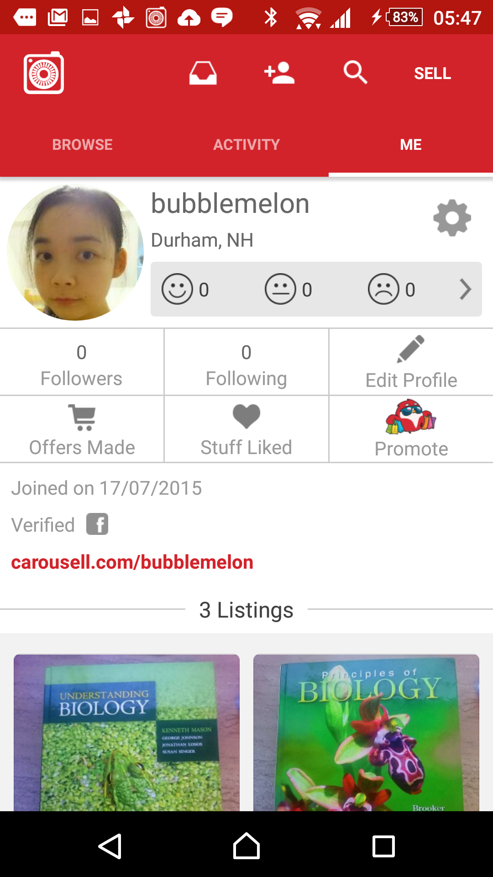

1. Requires you to insert/take a photo immediately to make a listing.

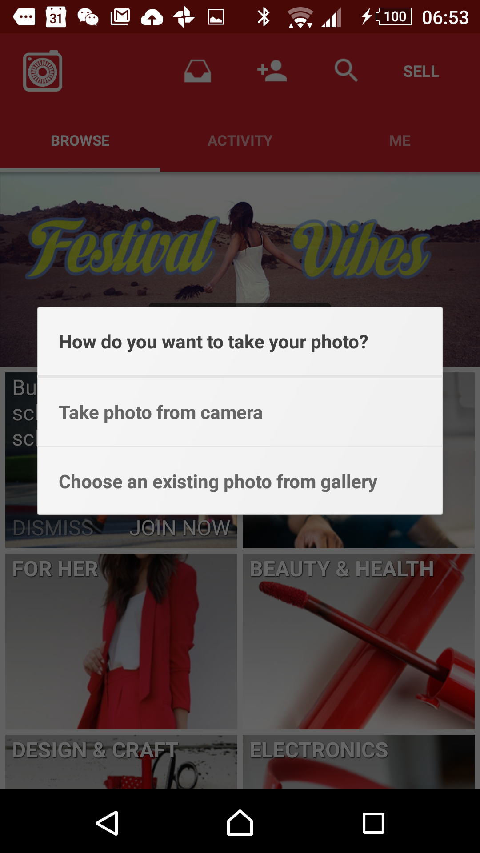



Updated: 9th August 2015

Advantages:

1. Banner photo.
2. My earnings.
3. Lets you place a description of anything – yourself, things you sell, etc.
4. Simple and organized profile interface.
5. Shows the time of the item listed.

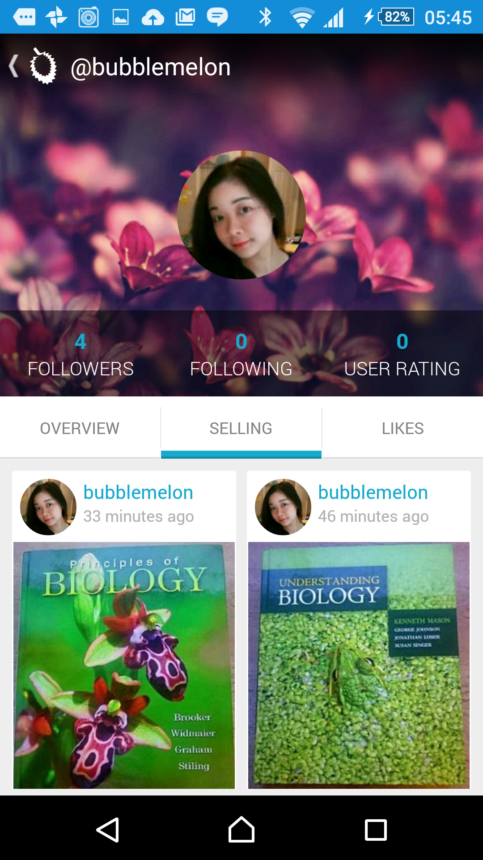

1. Item for sell layout is like Pinterest. Masonry grid.

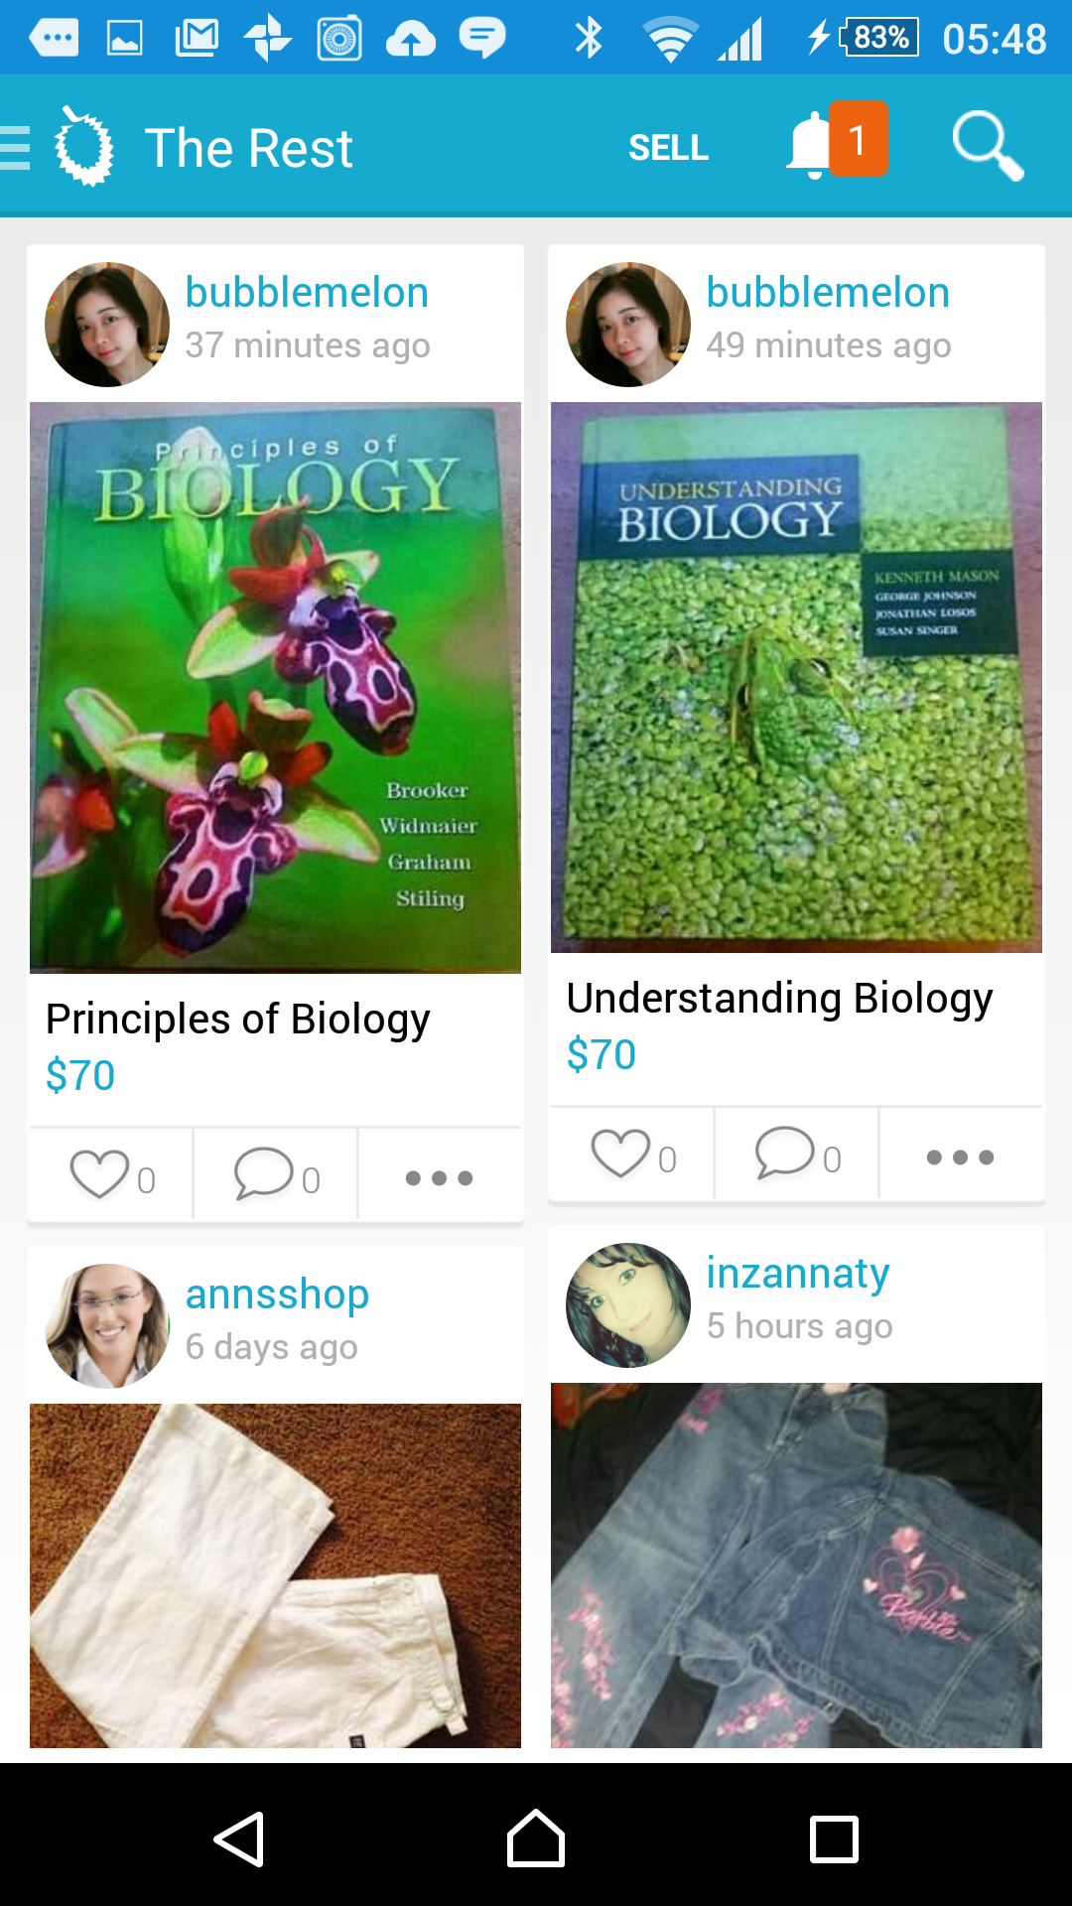

1. Browse by category.
   1. No filter, but has sub categories
2. Nice Side bar.

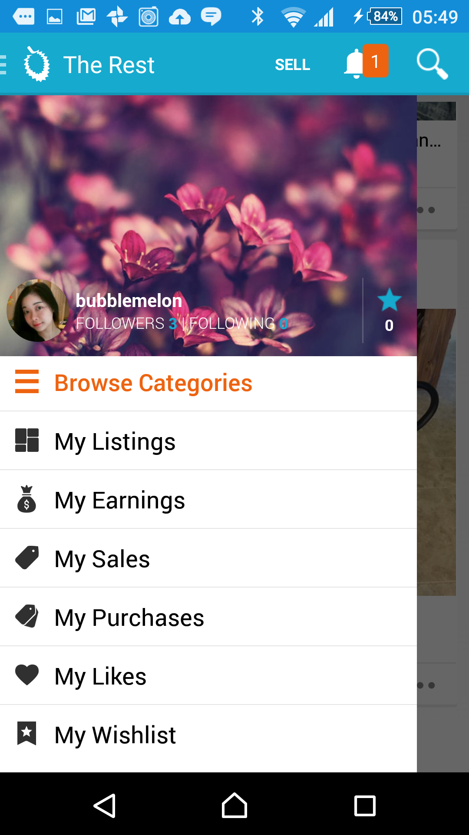 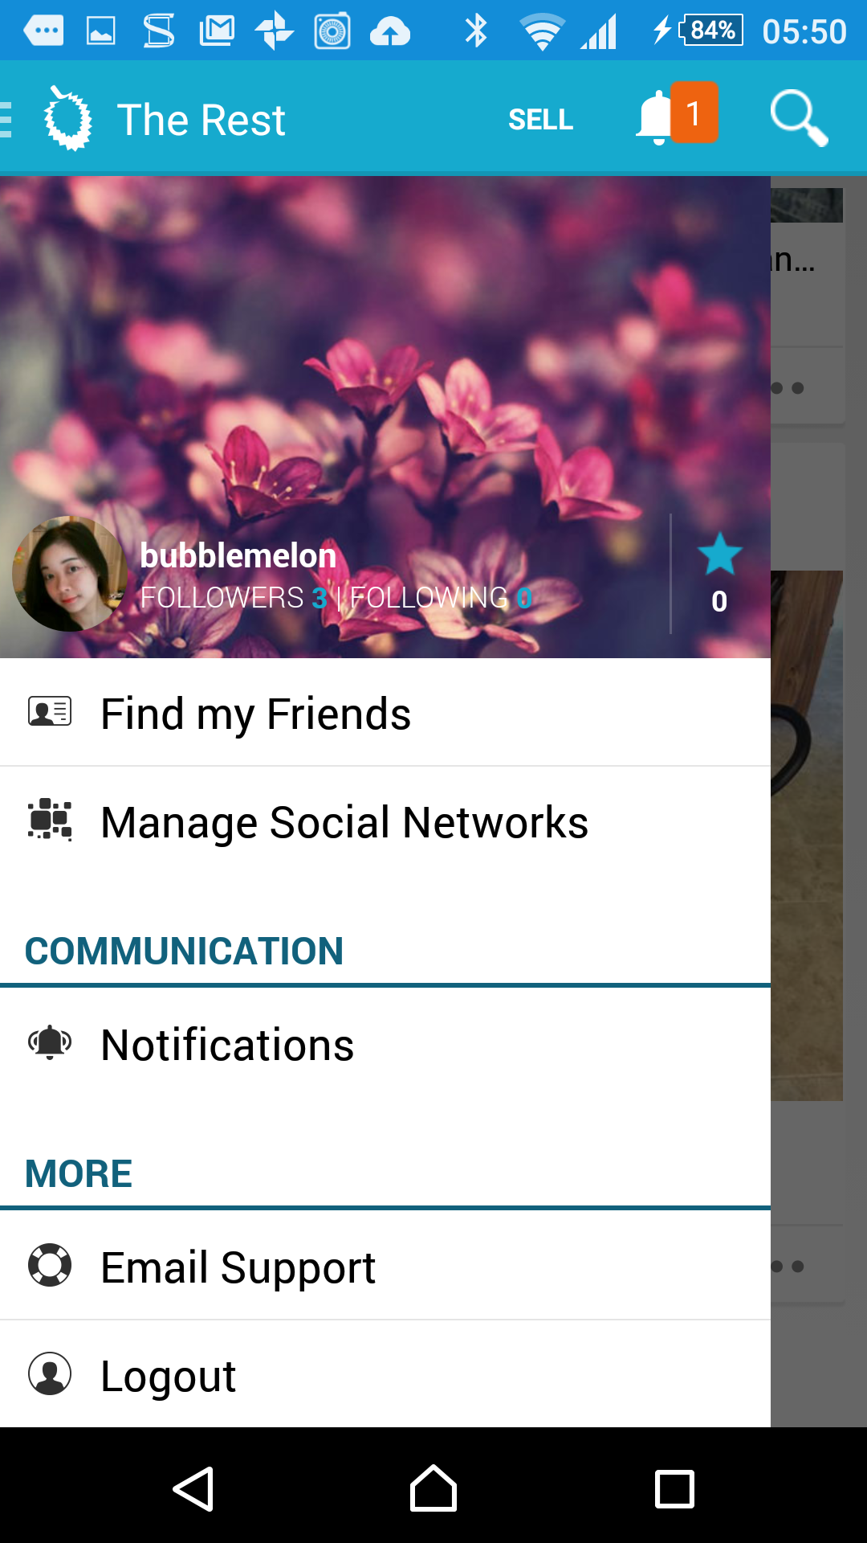

Making a listing

1. Tells you what type of photos you need to display.
   1. Photo for flaws.
2. Item info:

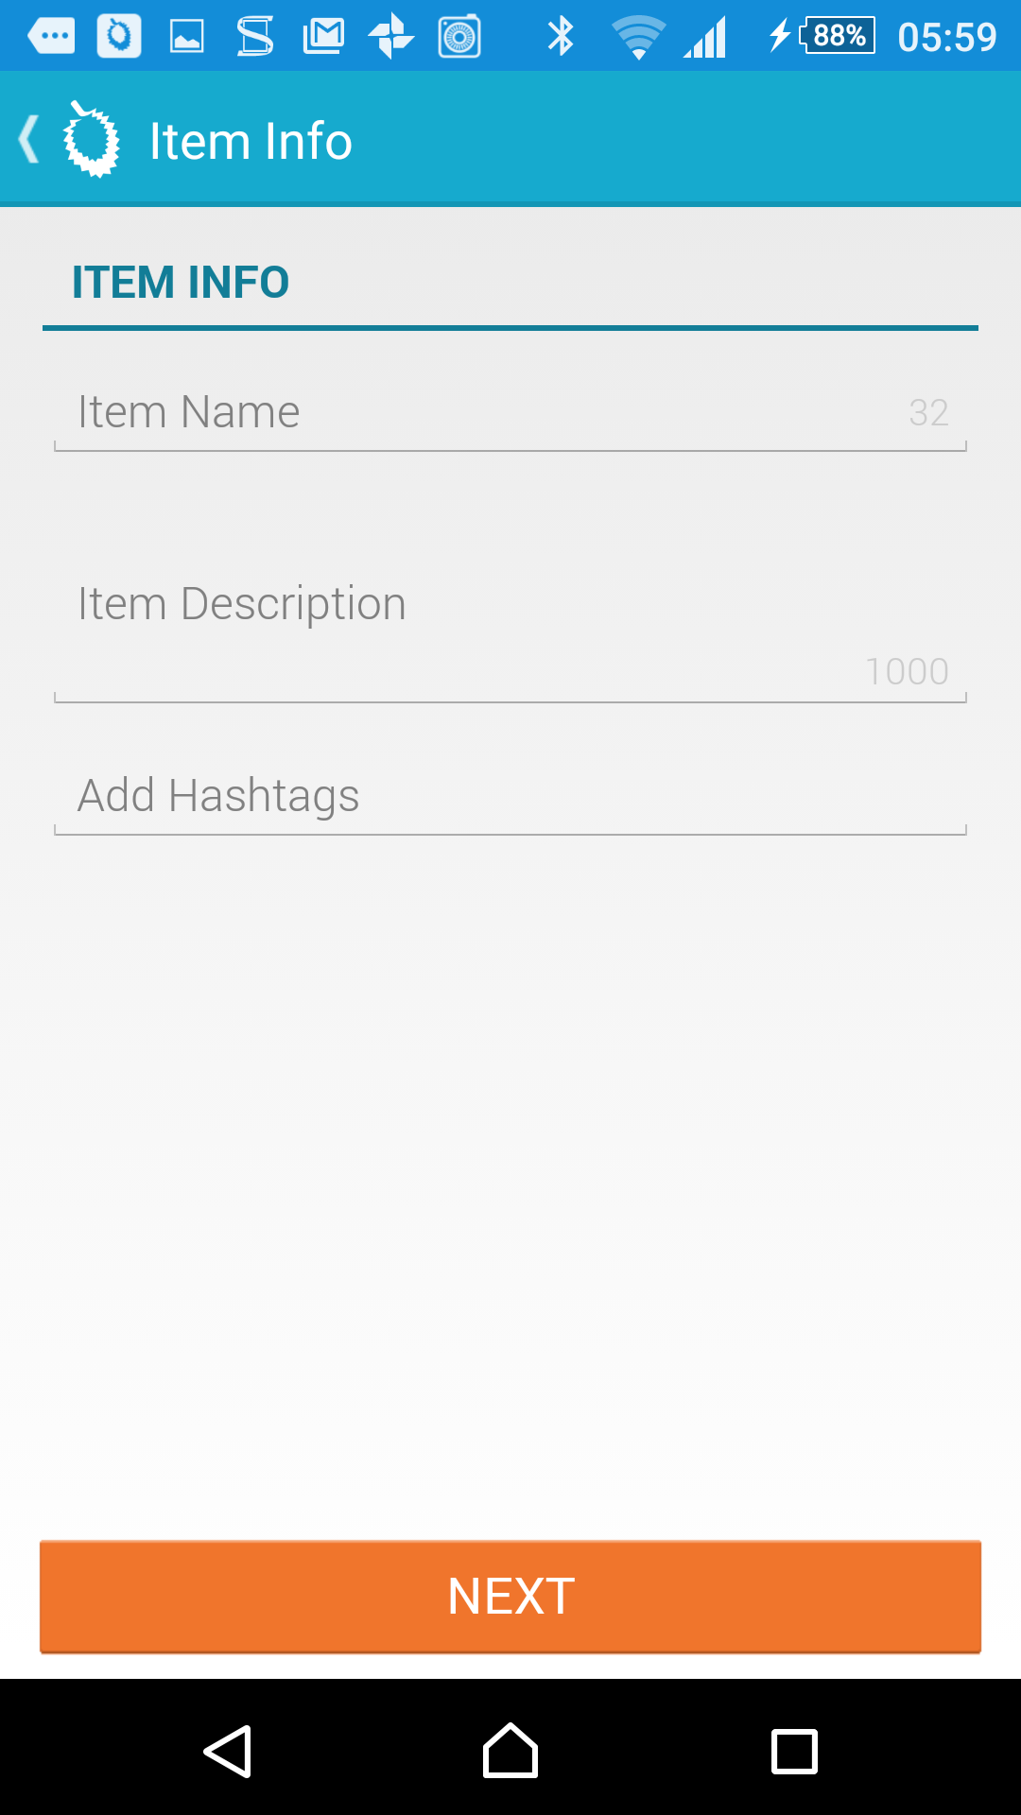

* 1. Item name and description has a character limit
  2. Add hashtags.

1. Must include:
   1. One image.
   2. Title of item. (Must have 5 characters)
   3. Item description. (Must have 5 characters)
   4. Category
   5. Brand
   6. Condition
   7. Meet up spot
   8. Selling Price
2. Get new followers after 10 minutes of posting a listing.

Disadvantages:

1. Automatically follows people you have on Facebook.
2. Can only use default banners.
3. **Designed mainly for selling clothes.**

Making a listing

1. Need to estimate shipping fees yourself.
2. Item Info
   1. Not intuitive.
      1. Does not save data you input when you press back button.
   2. Does not tell you if you have completed Item description.
      1. Sometimes, the item info section does save the data you input. Maybe it’s because of 2.
   3. Hashtags.
      1. Predefined hashtags may take some time to load.
      2. Hashtags kind of small so sometimes you may accidentally press the wrong one.



Updated: 9th August 2015

Advantages:

1. Does not require you to make an account when you start the app, if you just want to browse.

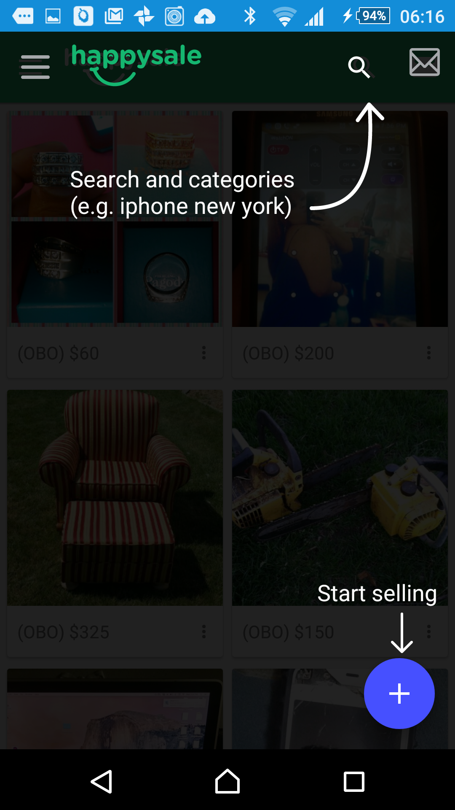 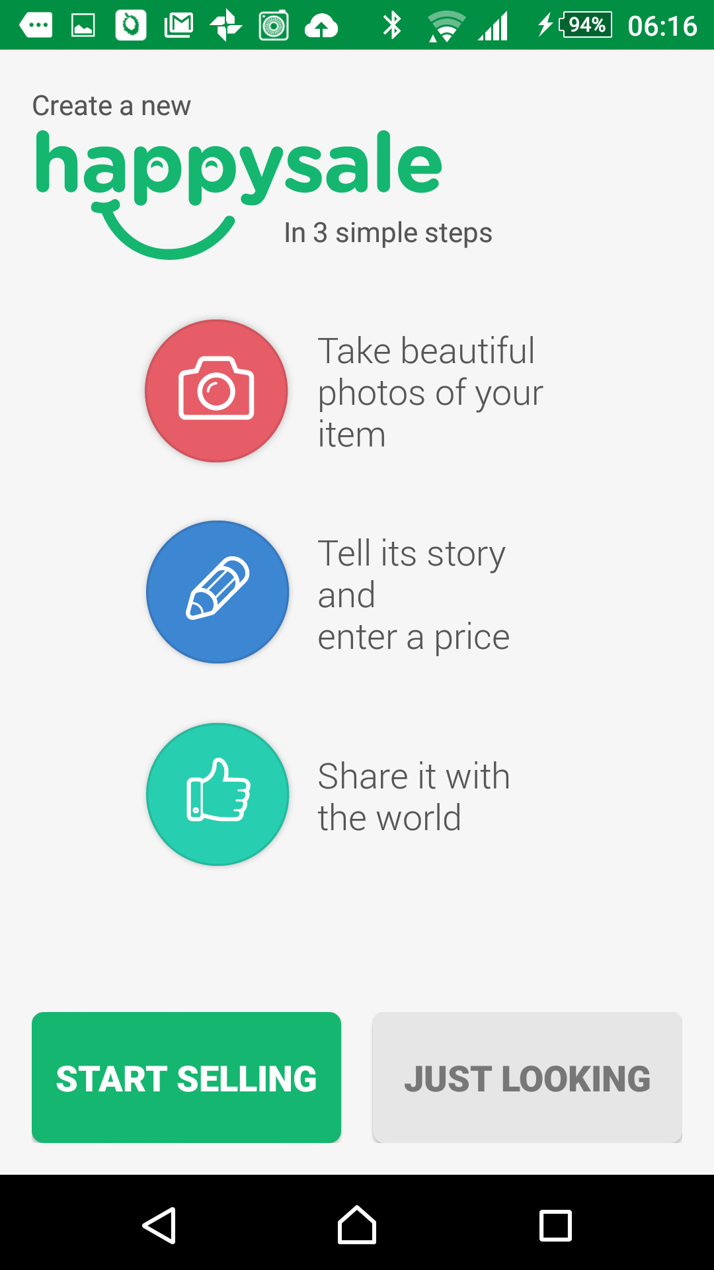

1. Bump your Happysale:
   1. Share with FB, Twitter and Google +

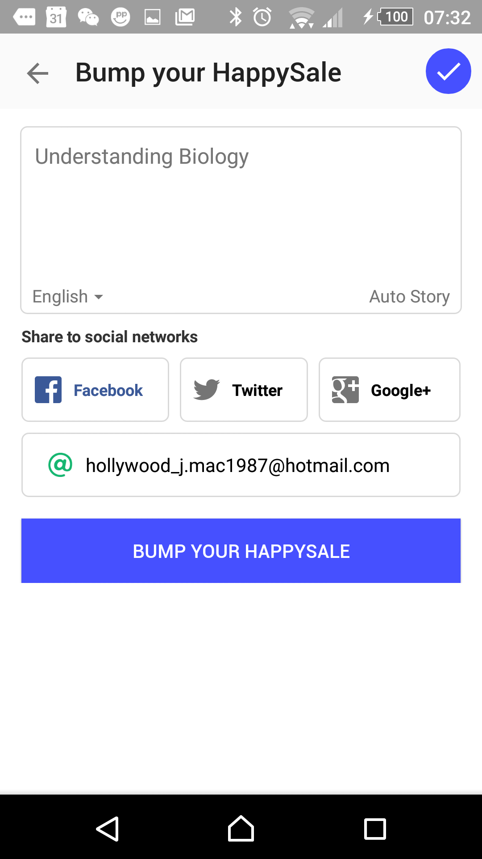

1. Simple side bar

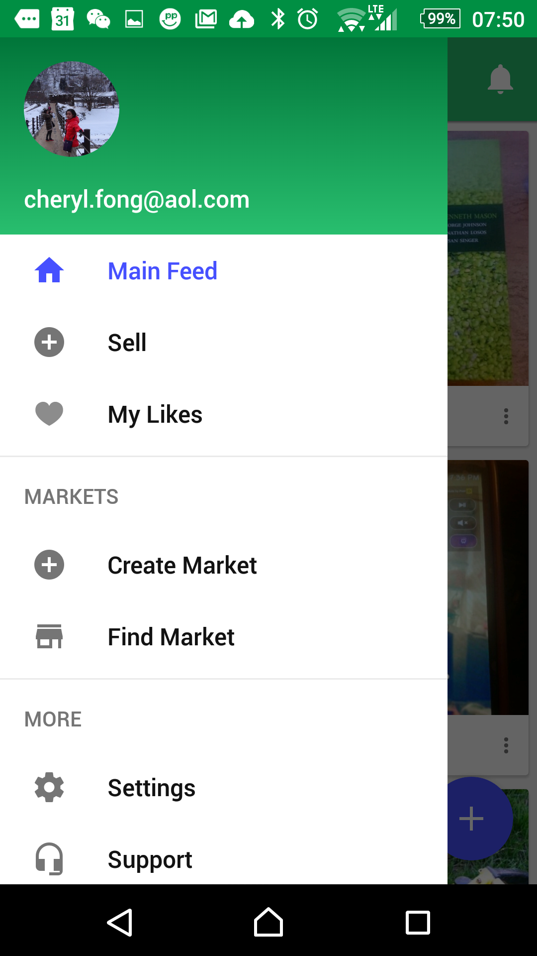 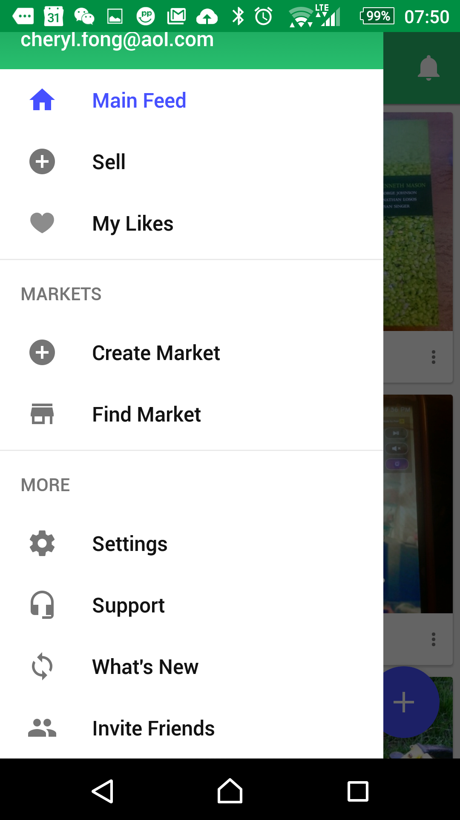

1. Create your own store:

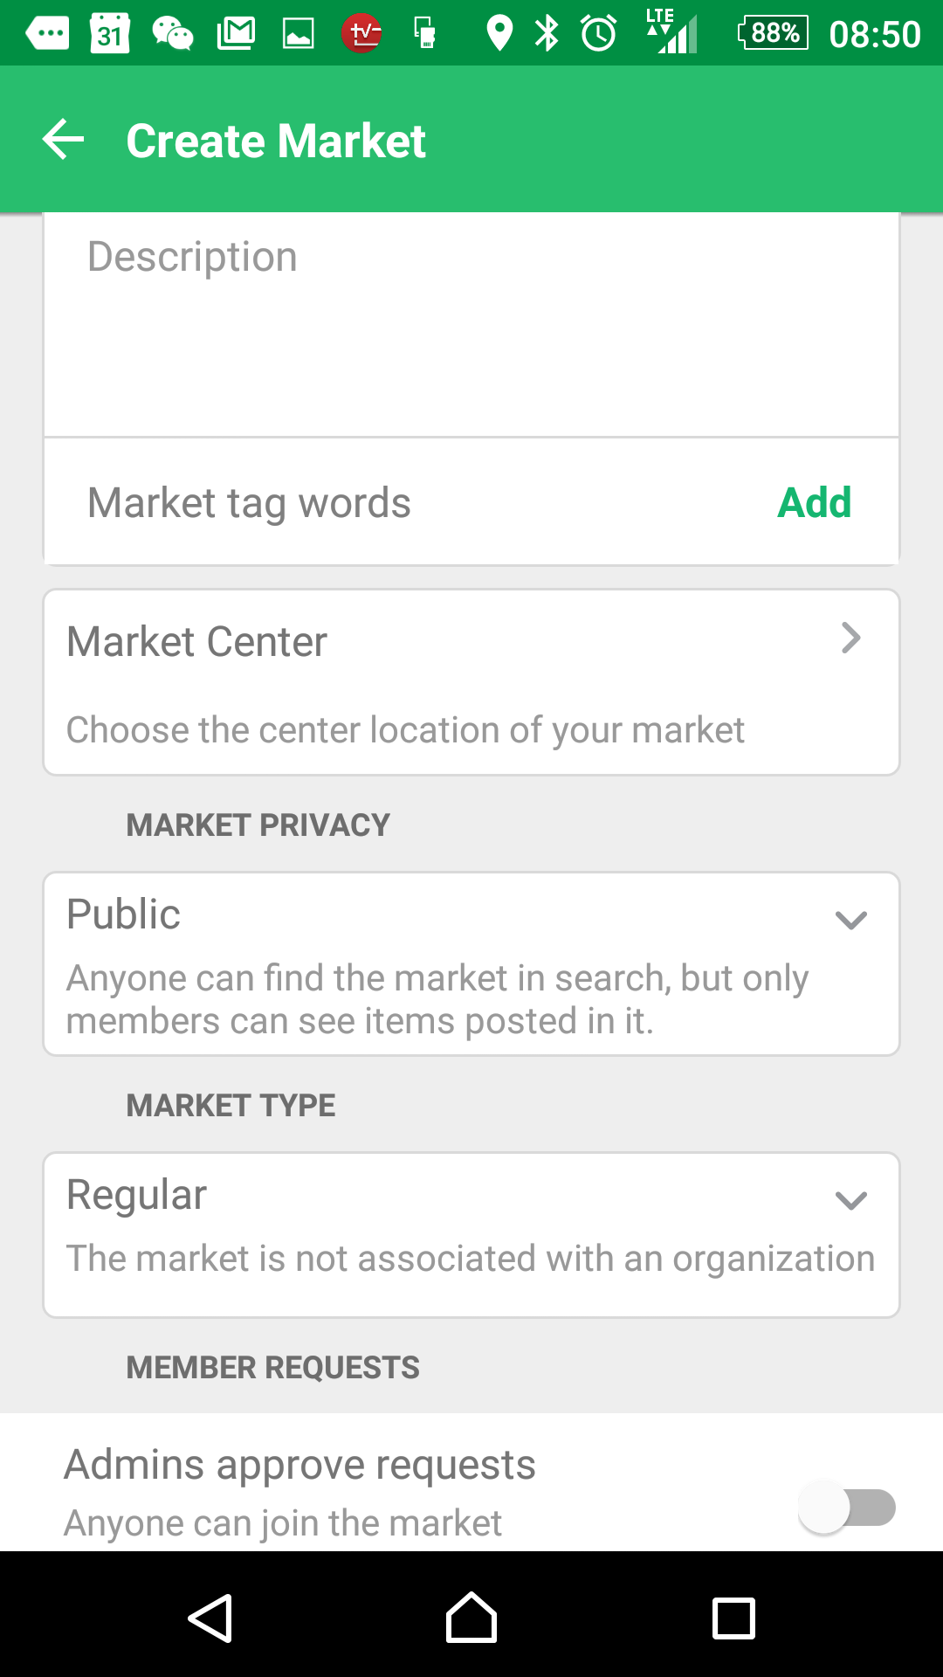 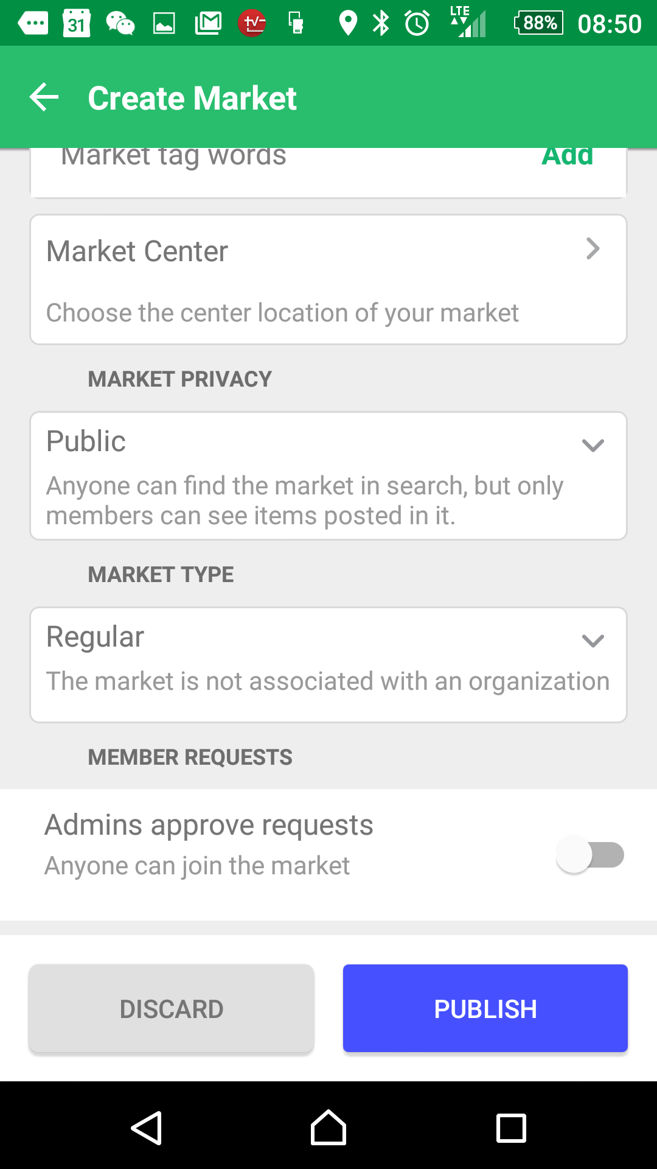

* 1. Needs to be reviewed by staff.

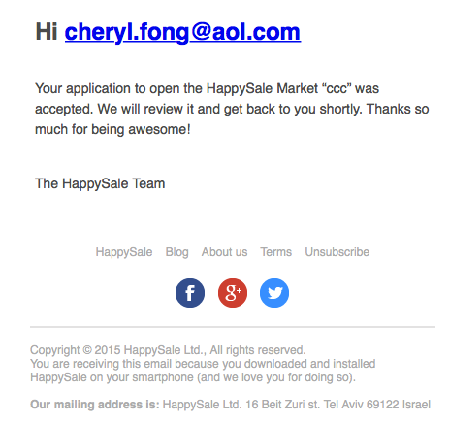

1. Making a listing
2. Continue listing where you left off.
3. Unlimited photos
4. Must include:
   1. One photo
   2. Item name (at least 3 characters)

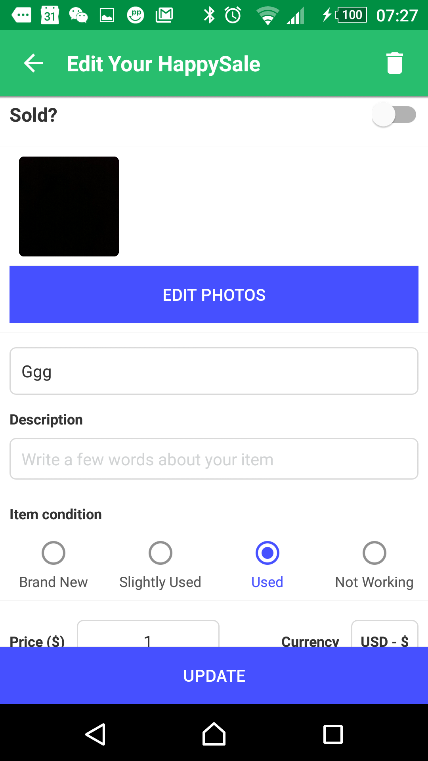

1. Advance search:

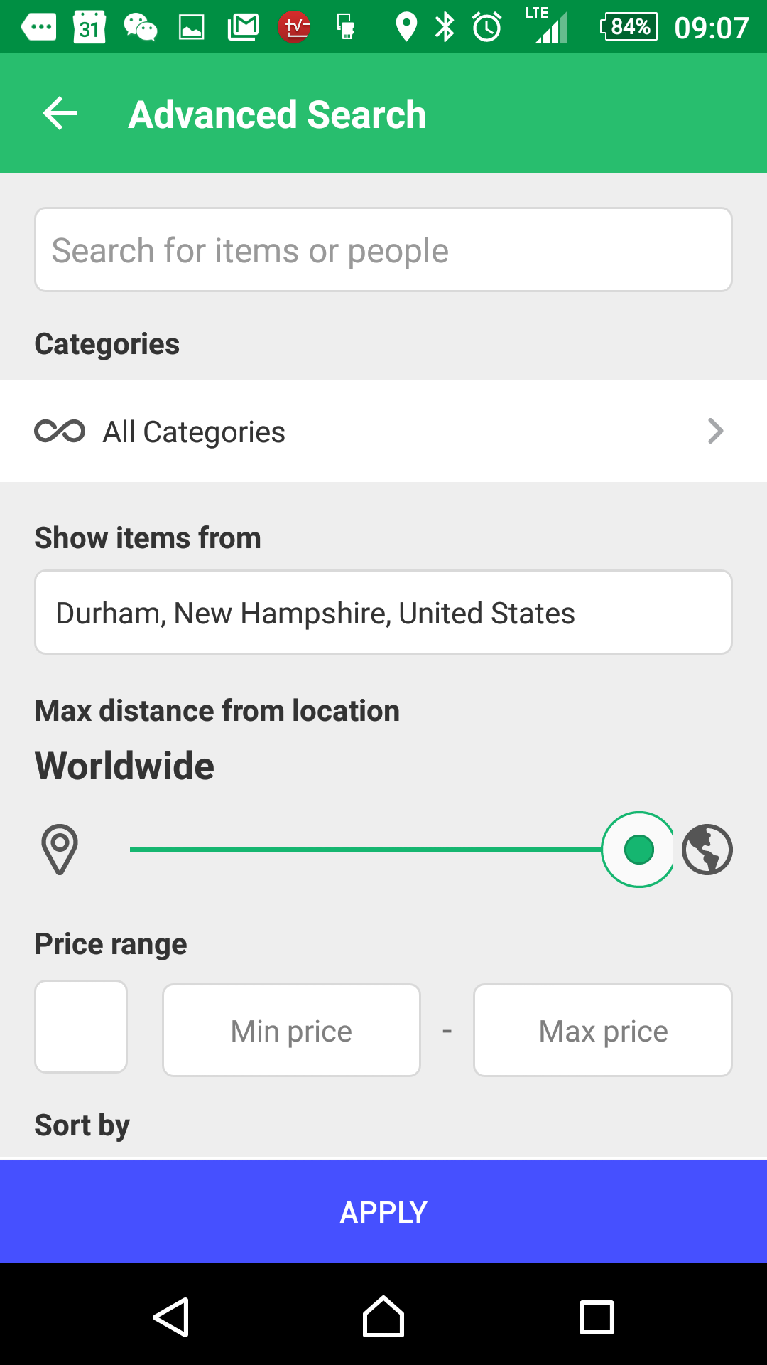 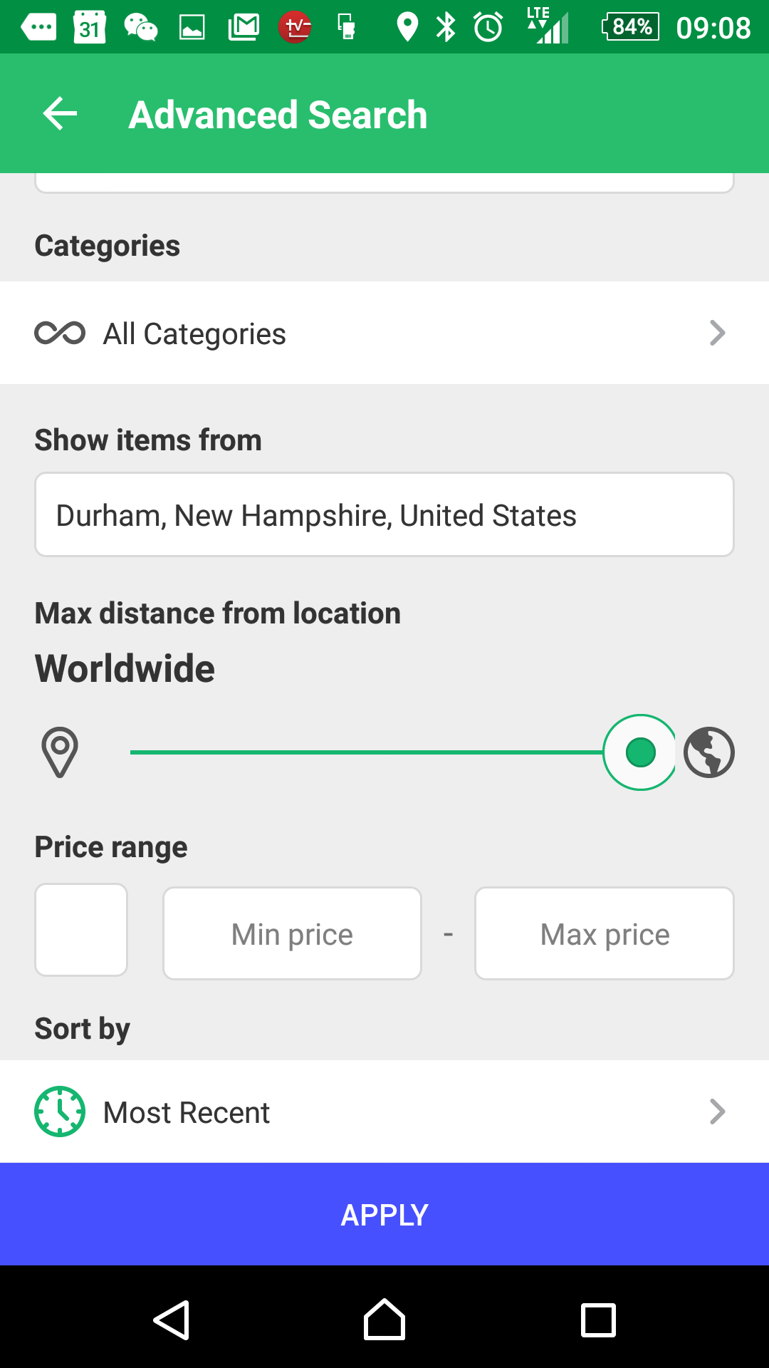

Disadvantages:

1. Promotion not free.

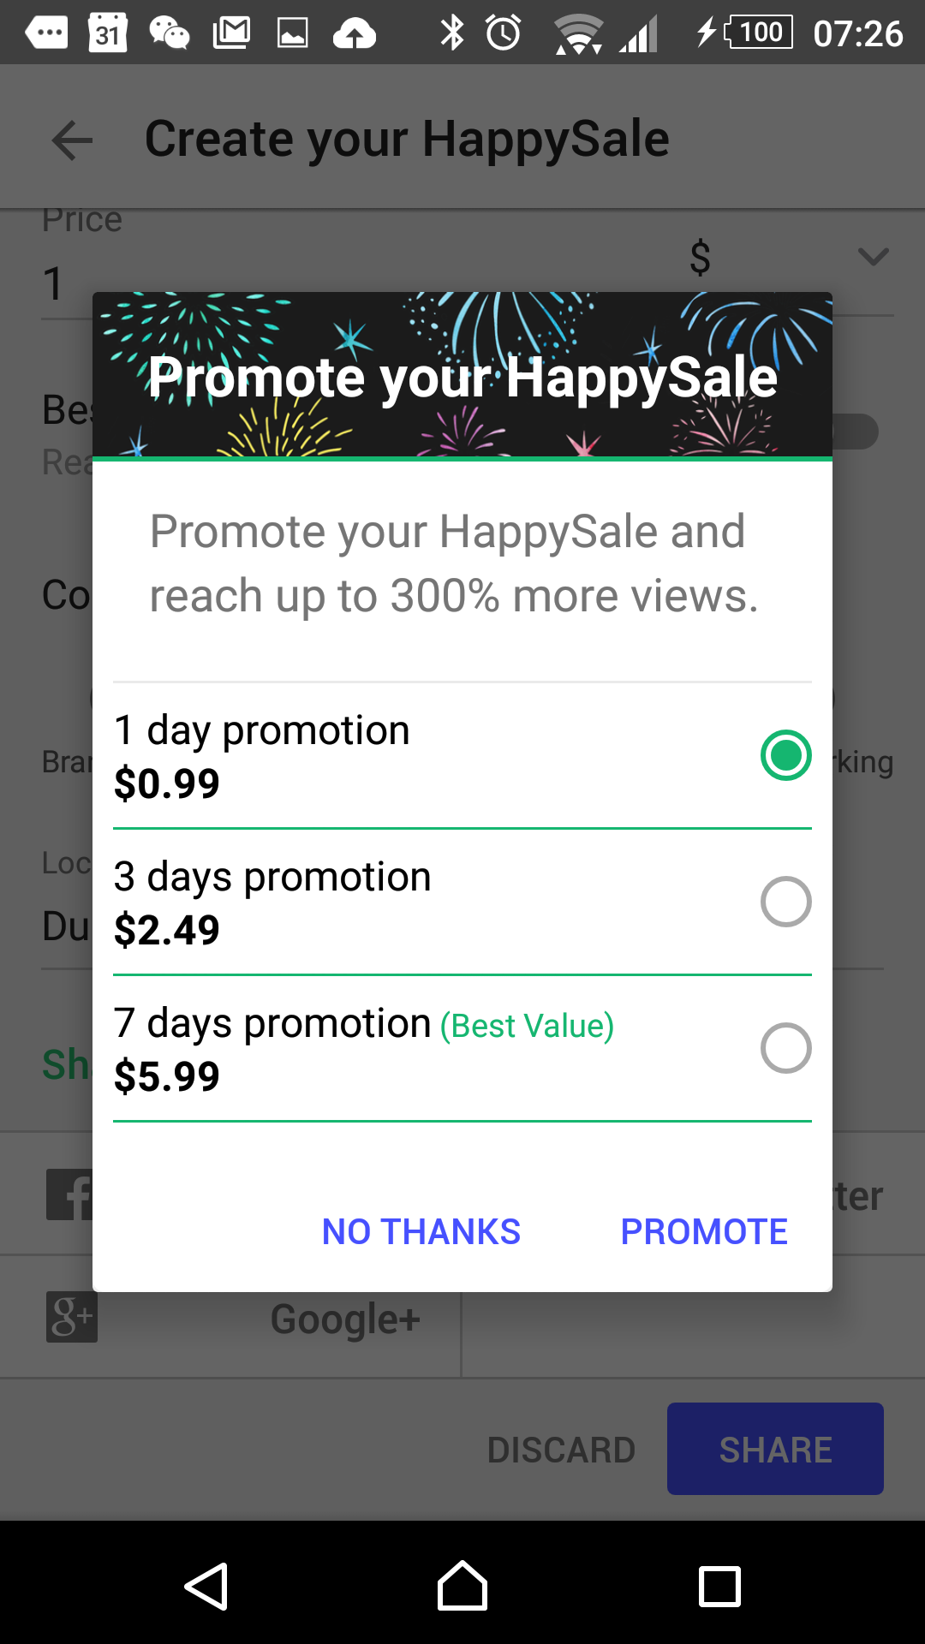

1. Not a lot of people use this app.
2. Sell button does appear sometimes.

Before logging in:

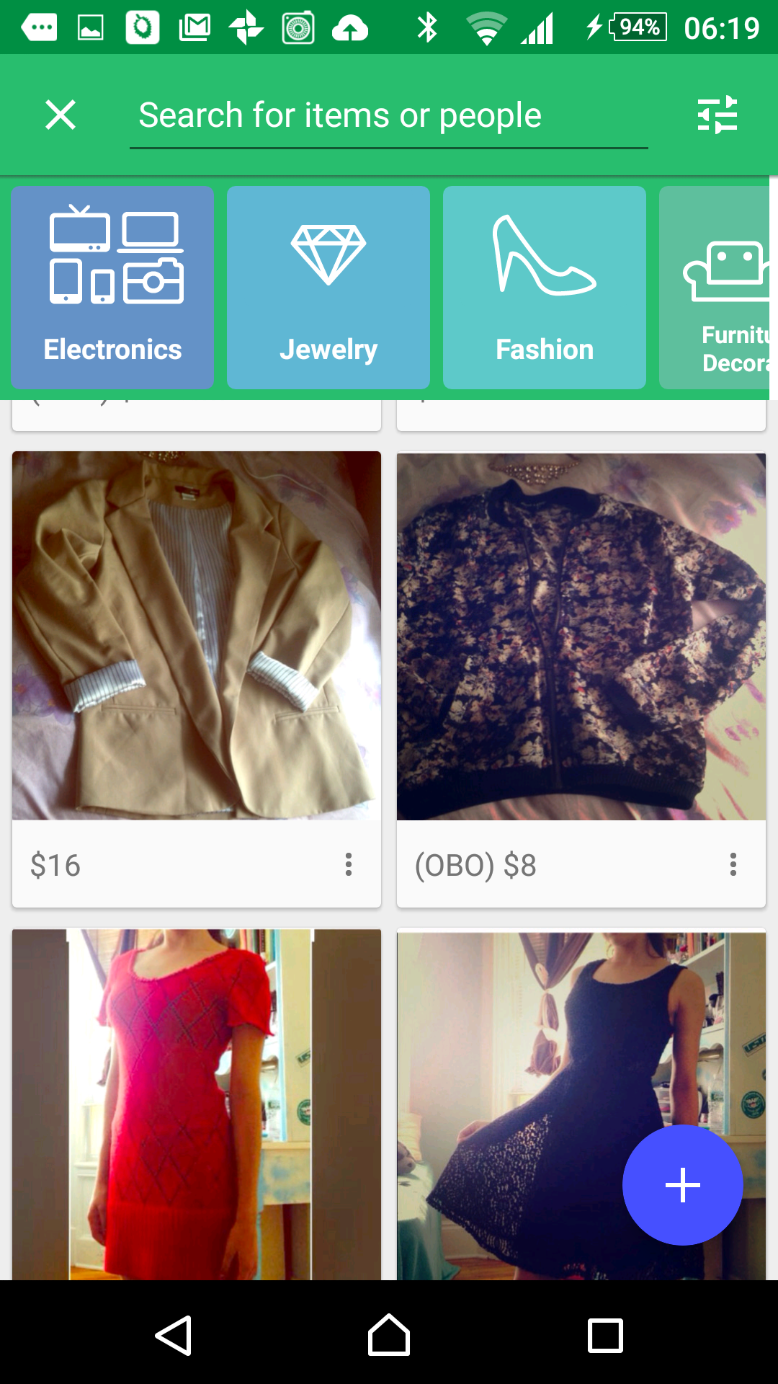 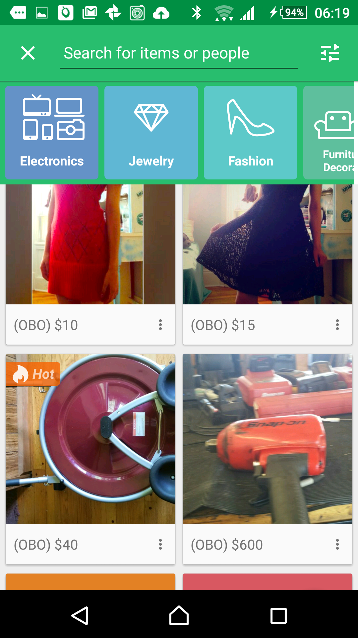

Need to touch the magnifying class to show category filter.

After logged in and made listing:

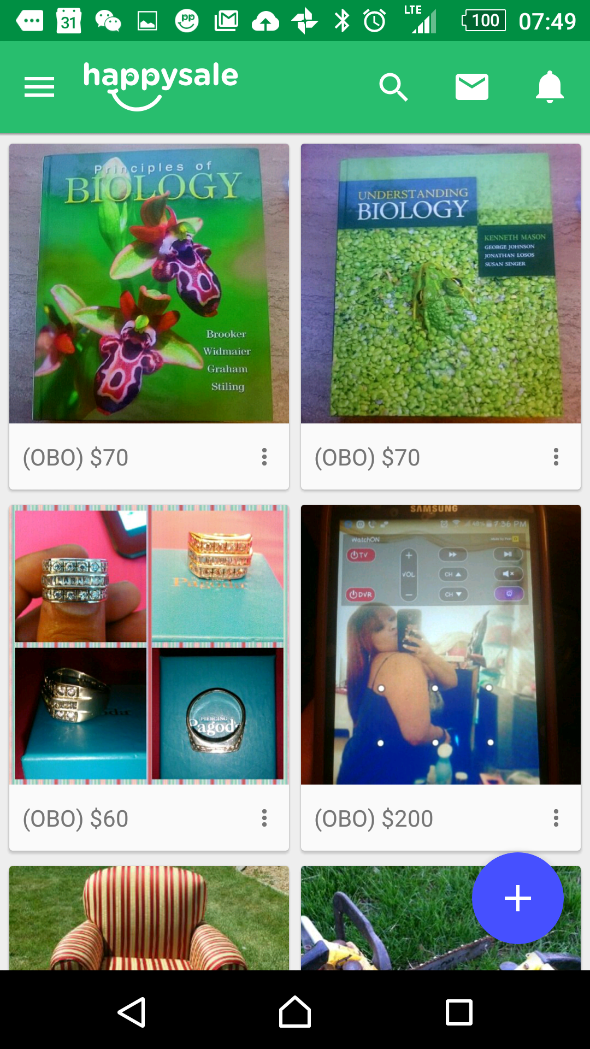 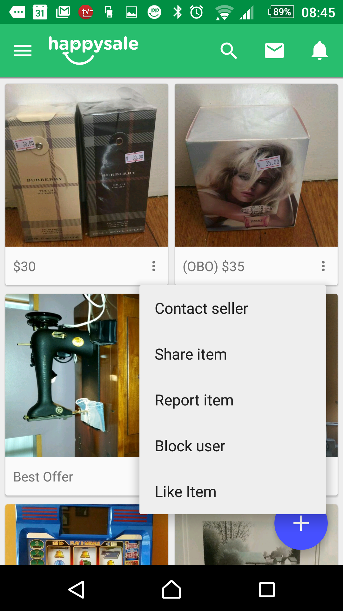

1. There’s an error with searching for market.

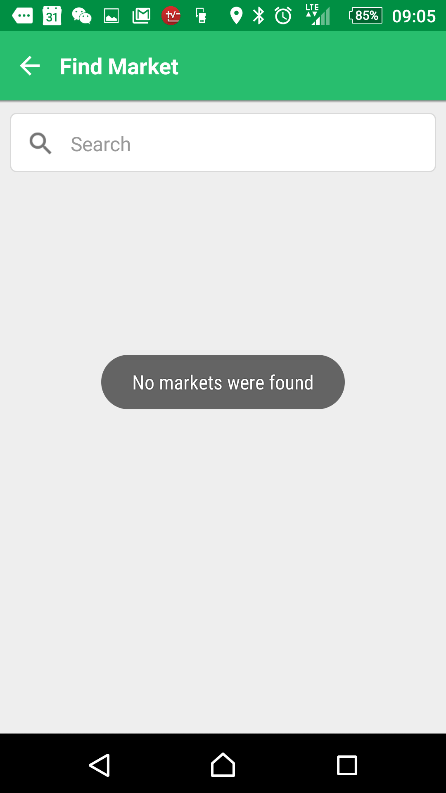

1. Cannot follow people
2. Cannot enhance photos
   1. Really bad photo feature as compared to Carousell and Duriana
3. Need to update sale, just like Carousell

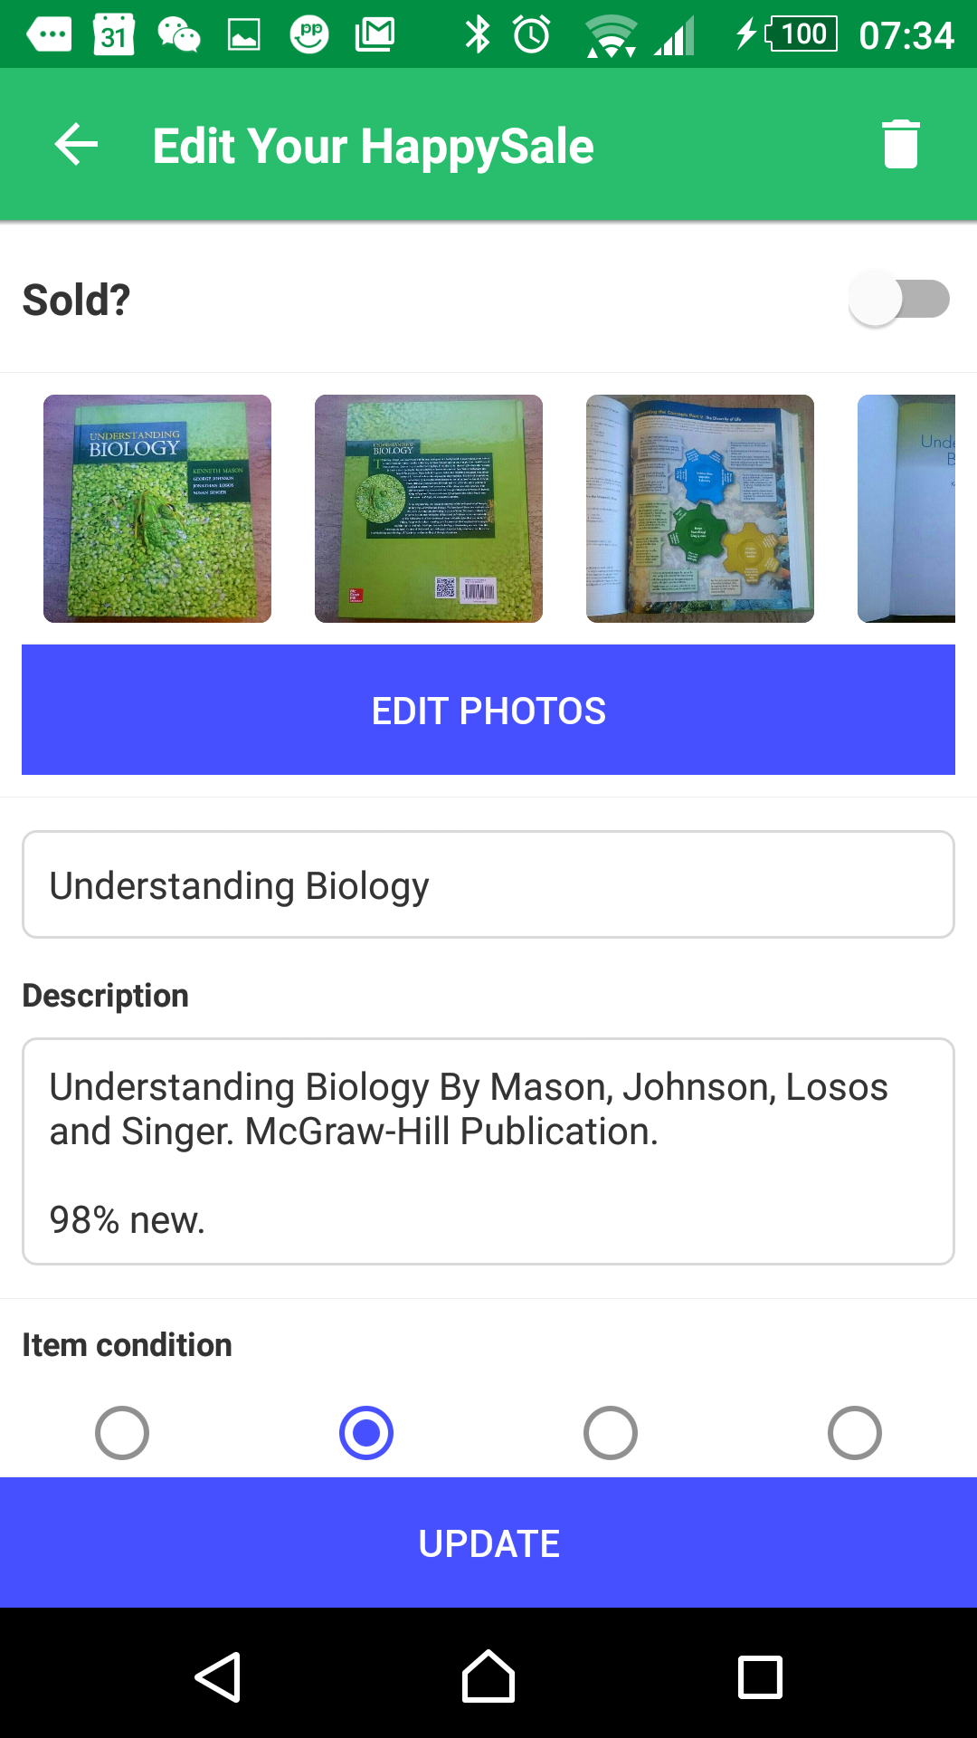 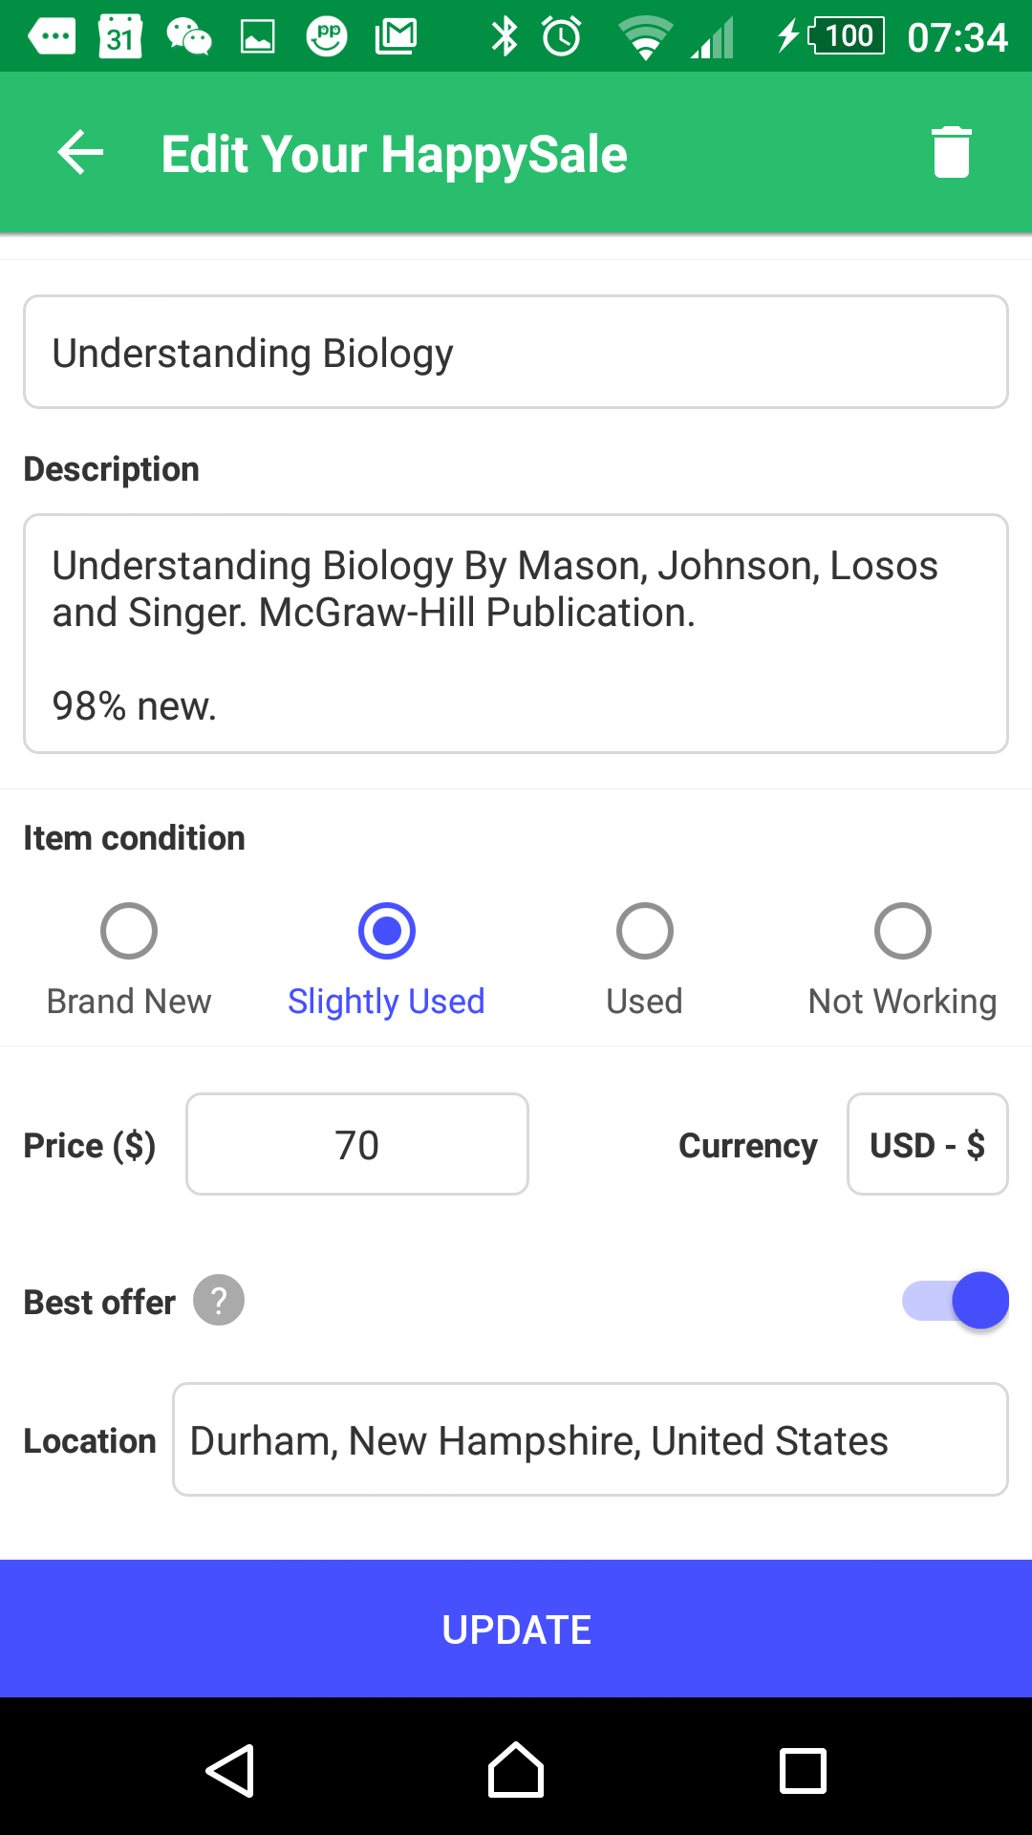

1. No profile personalization like Duriana.

